Ellen G. Landau

480 S. Orange Grove Blvd

Pasadena CA 91105

[exl3@case.edu](mailto:exl3@case.edu)

**Krasner, Lee (1908-1984) Word Count:** 484

Lee Krasner, born 27 October 1908 in Brooklyn, New York to immigrant parents from Russia, was an Abstract Expressionist painter whose status as the sole female pioneer of the movement is widely recognised. After attending the National Academy of Design and Cooper Union, Krasner’s talent blossomed at the Hans Hofmann School of Fine Arts, where she developed a radical understanding of the implications of modernism. Throughout her lifetime and long after, Krasner’s artistic career was overshadowed by her role as the wife (and widow) of Jackson Pollock. Credited by critic Clement Greenberg as ‘absolutely catalytic’ for Pollock’s aesthetic development, Krasner shrewdly managed his reputation and prices after his untimely death. This allowed her to establish the Pollock-Krasner Foundation in her will with a multi-million-dollar endowment to support needy and neglected artists. In her *Little Image* series, created after she and Pollock moved from Manhattan to Long Island in 1945, Krasner explored the possibilities of drawing (and sometimes dripping) in paint in a manner similar to Pollock. Krasner, however, retained traditional wrist control, avoiding Pollock’s improvisational whole-body movement. After his fatal automobile crash in 1956, Krasner moved into her husband’s barn studio where she produced oversized canvases featuring ferocious rhythms engendered with a vigorous backward stroke reminiscent of Hebrew calligraphy.

Starting with the *Little Images*, Krasner synthesized her initial enthusiasms for Pablo Picasso and Henri Matisse with Pollock’s recommendation that she come to terms with her own experience in her art. This directive, problematic at first, led Krasner frequently to revise works throughout her career, either by re-painting or through adopting collage techniques, at which she excelled. From 1953-55 she created an important collage painting series incorporating bits of Pollock’s discarded paintings and drawings (which he donated) and in the late 1970s she made an extraordinary set of oversized collages using her own Hofmann School-era figural sketches recently rediscovered. In *Eleven ways to use the words to see*, exhibited in 1977 at Manhattan’s Pace Gallery, Krasner combined into painted panels sharply sheared sections of charcoal figure drawings of that earlier era, as well as their rubbed-off ghost images. By re-contextualizing her past, she added a more personal focus to the idea of the allover composition pioneered by Pollock. By the time Lee Krasner died, on 20 June 1984 in New York City, she was considered a role model for feminist artists. The complexity of what has been characterized as her ‘working relationship’ with Jackson Pollock is a defining feature of her importance to the history of postwar American art.

**References and Further Reading**

Rose, B. (1982) *Lee Krasner: A Retrospective.* Houston, TX: Museum of Fine Arts, Houston.

Kuthy, S. and Landau, E. G. (1989) *Lee Krasner--Jackson Pollock: Künstlerpaare--Künstlerfreunde; Dialogue d'artistes—résonances*. Switzerland: Kunstmuseum Bern.

Landau, E. G. (1995) *Lee Krasner: A Catalogue Raisonné*. New York: Abrams.

Hobbs, R. (2000) *Lee Krasner*. New York: Independent Curators International and Abrams.

Levin, G. *Lee Krasner: A Biography* (2011). New York: William Morrow.

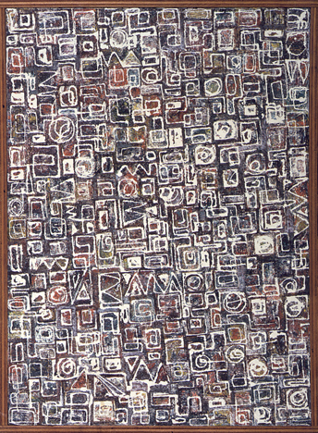

Lee Krasner,*Composition*, 1949. Oil on canvas. 38 1/16 x 27 13/16 inches (96.7 x 70.6 cm). Philadelphia Museum of Art. © Pollock-Krasner Foundation / Artists Rights Society (ARS), New York. <http://www.philamuseum.org/collections/permanent/57570.html>